Application Form

- Please submit FRONT and BACK clear picture of the Residence Card
- Complete the information needed and mail to the email address
sumojapanmobilepocketwifi@gmail.com
- Product Order
(Pocket Mobile Wifi or Home Internet)
- Complete Name
- Complete Address
City
Prefecture
Zip code
Apartment name/ building name
Room number
- Contact Number
- Facebook Name
- Facebook email address
- Facebook URL/ Link
- Reference Person
- Reference Contact number
- Delivery Date
- Delivery Time

Delivery is 1-2 days thru Sagawa Express for mobile pocket wifi. Please sign and Mail back the INFORMATION SHEET that comes with the package the day after delivery to avoid penalty or internet loss.

Pls visit and Like: https://www.facebook.com/estorejapan/
Do you want to get the Softbank Pocket wifi or the ZERO Cash Out Unlimited Home Internet

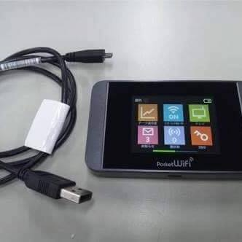
1. 50gb monthly – Fast Softbank Pocket mobile wifi
*price: ¥6,980 monthly (no extra cost)
*no contract
*device free of use (has to be returned in good condition when cancelling the service to prevent penalty)
*Free Shipping
*powered by Softbank
*Initial payment is Cash on delivery
*Very easy to pay you will receive a bill every first week of the month ans pay it at any convenience store like 7eleven and familymart or etc.
*bill is every 15th of the month

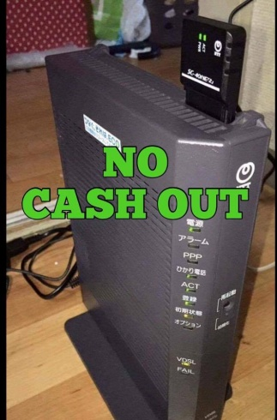
- Hikari Unlimited Home Internet (Fiber Optics)
7,400 JPY Monthly for Stand Alone Internet
2 years contract
3,000 JPy One time activation fee
Modem router free to use
Super fast Unlimited home internet
NO MONEY CASH OUT on the day of installation
1st payment is on the next month after installation
due date is every 25th of the month

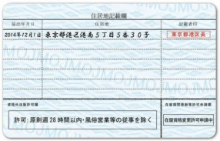
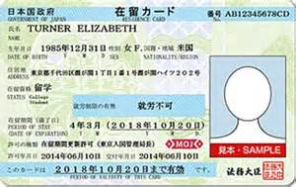

Front Back (Residence Card)

